**IoT Based Air Quality Monitoring System**

**Introduction:**

The Project involves setting up IoT devices to monitor environmental conditions in public parks, including temperature and humidity. The primary objective is to provide real-time environmental data to park visitors through a public platform, enabling them to plan their outdoor activities accordingly. This project includes defining objectives, designing the IoT sensor system, developing the environmental monitoring platform, and integrating them using IoT technology and Python.

**Design Thinking:**

|  |  |
| --- | --- |
| * Project Objectives: Define objectives such as real-time environmental monitoring, aiding park visitors in activity planning, promoting outdoor experiences, and enhancing visitor satisfaction. * IoT Devices Designs: Plan the deployment of IoT sensors (e.g., temperature and humidity sensors) in public parks. * Environmental Monitoring Platform: Design a web-based platform to display real time environmental data to the public. * Integration Approach: Determine how IoT devices will send data to the environmental monitoring platform. |  |

**Components Required:**

**Hardwares:**

* **Sensors,**
* **Microcontrollers, and**
* **Communication modules.**
* **Power Supply**
* **Enclosure**

**Softwares:**

* Cloud platform,
* A mobile application, and
* A web-based dashboard.
* Git Application
* Programming Language(Python)

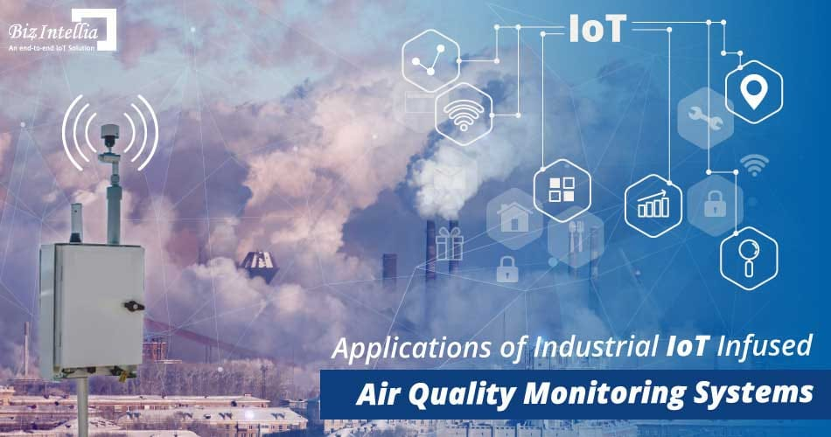

**Need for Air Quality Monitoring System :**

**IoT (Internet of Things) plays a crucial role in reducing air pollution through its ability to collect real-time data and enable smart decision-making. IoT devices, such as air quality sensors, can monitor pollutant levels in various environments, including cities, industries, and homes.This data can be analyzed to identify pollution sources, implement targeted mitigation strategies, and track the effectiveness of pollution control measures. IoT-enabled smart city solutions optimize transportation, waste management, and energy consumption, reducing emissions and improving air quality.Furthermore, IoT-based personal air quality monitors empower individuals to make informed choices and avoid high-pollution areas. By leveraging IoT technology, we can proactively address air pollution, create sustainable solutions, and promote healthier environments for present and future generations.**

**Conclusion:**

**In conclusion, an IoT-based air pollution monitoring system is a revolutionary solution that can provide accurate and real-time data about the air quality in a particular area. It can help identify the sources of pollution and take necessary measures to reduce it, protecting the environment and human health.With its scalability and versatility, the IoT-based air pollution monitoring system can be used in various settings and integrated with existing air pollution monitoring systems, making it an ideal solution for air pollution monitoring.**

**Project Submitted by,**

NAME: Maheswari M

E-MAIL ID: Maheswarimaheswari707@gmail.com

NAAN MUDHALVAN ID:au713921106025

COLLEGE CODE:7139